**Presentation Notes**

1. Summarize the main features of a Code Repository
2. List some differences between a Code Repository and other file sharing services

1. List some of the reasons why we are using GitHub in this course
2. You will be using 2 different GitHub repositories in this course. Explain what they are:
3. Label the following parts of the GitHub interface using the diagram below.
   1. File content link
   2. Timestamp information
   3. Button to upload files
   4. Repository link & path information

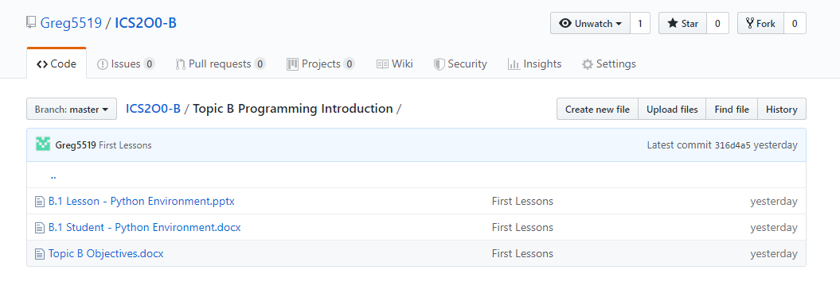

1. List some privacy concerns related to using GitHub.
2. Summarize the guidelines you should follow when creating a user account for school work on 3rd party software.
3. List some of the main features of a Terns of Service (TOS) agreement.
4. List some of the main features of a Privacy Policy.
5. Summarize the difference between a TOS and a Privacy Policy.

**Module Questions**

1. Review the Terms of Service (TOS) agreement for the GitHub service.
   1. Open the link: (<https://help.github.com/articles/github-terms-of-service/>)
   2. Summarize the section that confirms that you are permitted to use this software for this class.

Section C: Acceptable use, explains we are able to use this software for class purposes. We are able to use this service in class, though we must not break any laws, like copyright or trademark laws. With the use of this service, we are responsible for making sure we are compliant with laws and regulations

* 1. Explain what rights do you give up by using this software.

Section D explains the rights we give up. They include giving the legal right to do stuff like host my content, publish it and share it. I give GitHub the right to store, parse and display my content.

* 1. Explain what limitations you have when using this software.

GitHub will not be liable for damages or losses from my use of inability to properly use the service. GitHub will not be liable to me or any third party for any profit loss, or data or any type of damages.

1. Review the Privacy Policy for the GitHub service.
   1. Open the link: (<https://help.github.com/articles/github-privacy-statement/>)
   2. What information does GitHub collect and track?

GitHub collects basic information when you create your account, like our email address, though you have the option to give more info if we want to or not. They collect technical info to better understand how people to visit GitHub use the website. They collect info from third parties, for purposes which it is allowed to be collected in, such as contacting us for marketing purposes.

* 1. Summarize how GitHub shares your information.

GitHub shares personal information with our permission, so they can perform services we have requested. They share our personal info with our permission to limited third parties, who process it on GitHub’s behalf to improve GitHub’s service. Their vendors perform services like payment processing, customer support ticketing and other similar services.

* 1. How does GitHub communicate with you?

GitHub uses our email address to communicate with us, if we have agreed to that being okay, and only reasons we have said are okay. We are able to change our communication preferences in user profile

GitHub will be used to share course files in a similar way to MyClass or D2L. The reason we are using GitHub is because this is the tool preferred by many software developers and is the most common way to share computer code on the internet.

The Peel School Board is concerned about the privacy and safety of its students and has issued the following guidelines for using third party applications:

* Do not provide: First & Last Name
* Do not provide: Birthday
* Do not provide: Personal Address & Contact Information
* Do not provide: Student Number
* Your @pdsb.net email address can be used but cannot be used as a login id.

1. Based on your understanding of the GitHub privacy policy, list two benefits and two drawbacks of following the Peel Board guidelines listed above.

2 Benefits are that GitHub does not ask for your birthday, or does it ask for personal address.

2 Drawbacks are that we have to give them our student number for our email address and contact information.

1. Create an account on GitHub.com following the Peel Board guidelines listed above.
   1. **NOTE:** Make sure to select the free student plan when creating your account.

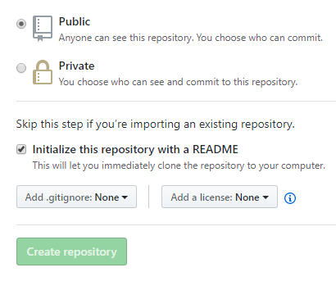

1. Create a new Repository for your ICS2O0 course work.
   1. Give your repository a meaningful name like “ICS2O0_Work”
   2. **Note:** Make sure to select "Public Repository"
   3. **Note:** Make sure to select “Include a ReadMe file”
2. Email Mr. Nestor (p0079141@pdsb.net) the following information:
3. Your Name
4. The link to your repository

Your personal GitHub repository will be used to store and manage your work for this course. You should save partially completed work in your repository and you can update it at any time from school or at home. GitHub automatically keeps track of updates to your files. You should NEVER make multiple VERSION COPIES of your work files.

Your repository should be shared with your teacher and with other members of your work group.

1. Open Mr. Nestor's repository for this class.
   1. You should have bookmarked the link in an earlier part of this lesson.
   2. This repository is the source for all course information and lesson files (much like D2L or Google Classroom is used by other teachers).
   3. Note the structure and organization of Mr. Nestor’s repository. In particular, note the folders such as “Topic A”, "Topic B", etc.
2. Duplicate the organization structure and folder names in your personal repository.
   1. Your personal GitHub repository will be used to upload and manage your work completed for this course.
   2. Your repository needs to be well organized so that Mr. Nestor can easily find your work and give you credit for it.
   3. **NOTE:** There is a “trick” required to create folders in GitHub.
   4. See if you can find this trick and share it with your neighbours.
   5. Check-in with Mr. Nestor to make sure you have found the trick.
3. Upload your answers to this module (i.e. the “A.1 Student - GitHub Repositories” )
   1. Make sure to store it in the proper folder.
   2. Use the "Upload" button in the GitHub screen and drag and drop you file.
   3. Make sure to "Commit" your changes at the bottom of the upload screen.
   4. You can upload and commit partially completed work now and then upload the same file again at a later time; GitHub automatically keeps track of your changes.

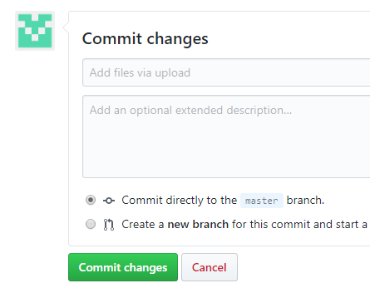

1. Email Mr. Nestor ([p0079141@pdsb.net](mailto:p0079141@pdsb.net)) when you have completed this work.

Work will be submitted (handed in) by uploading it to your repository . ONLY work uploaded to your repository will be considered handed in and will be marked.